

Eidoo — May Blog Post #2

25 May 2021

Prepared by AmaZix

Instant SEPA in Eidoo Wallet

"*Your transfer hasn't arrived yet*".

Even in these times of crypto wallet applications, we have been on the receiving end of this notification as if that intangible limbo in which our fiat money is in when it is in transfer mode was something inevitable. As if for that time, that money — our money — was not ours or anyone else's.

*"A right delayed is a right denied."* Martin Luther King Jr.

The truth is that despite the complexity of all matters related to money and ownership it can present, methods have been improved to streamline its handling. We are talking about the Single Euro Payments Area (SEPA).

# What Is Instant SEPA?

A coordinated financial change of the complexity to harmonize payment sectors in several countries is, of course, a daunting task. SEPA was, therefore, not built in a day. Work had been done since 2008 on creating a unified set of rules to facilitate the integration of the economies of the European Economic Area (EEA). This is the framework that gave birth to SEPA.

Starting with the definition, Instant SEPA is the colloquial term for SEPA instant credit transfers. SEPA is an EU initiative to simplify cross-border money transfers in euros and includes all EU member countries plus special territories and those with strong economic ties to the Eurozone. Its success has been astounding, and in fact, it has replaced national payment systems in the Eurozone from 2011 onwards.

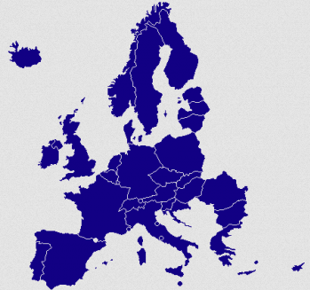

Source: <https://www.b2bpay.co/sites/default/files/resize/field/image/sepa-countries-350x328.png>

But SEPA takes time.

It took time to be implemented, but it also takes time to execute payment orders. The reason for this is that the system itself is processed in batches so that a euro bank transfer can arrive on the same day or the next day, depending on which batch it enters when the time comes for it to be executed.

This is the problem that Instant SEPA solves.

Instant SEPA has many advantages over the original SEPA method.

* Instant SEPA operates constantly 24/7/365.
* The delay that a transaction can take goes from days to seconds. Specifically up to 10 seconds for each transfer.
* The maximum amount for each euro bank transfer is €15,000, a figure more than enough to meet the vast majority of transfers needed by any person or small business in a day. Exceptionally this limit can be extended to €100K upon agreement between the institutions that manage the operation.

As a requirement, and linking to this last point, in order to have the possibility to use this type of transfer, it is necessary that both financial institutions that participate support Instant SEPA. This is, in fact, the case for most of them in the participating countries.

# Instant SEPA in Eidoo

Eidoo enables you to make Instant SEPA transfers directly from your crypto wallet, making the experience of entering and investing in the crypto world much more enjoyable.

Moreover, using instant SEPA is completely transparent for you — the user. You will simply notice that when you make your investments from fiat accounts that support Instant SEPA your money arrives immediately, as it should.

Instant SEPA transfers within the Eidoo wallet can be made with your USDC, USDT, and DAI funds receiving euros in your bank in seconds. Aside from having residence in the EU, the only requirement is that you must have tier 2 validation completed to be able to trade with euros and transfer them.

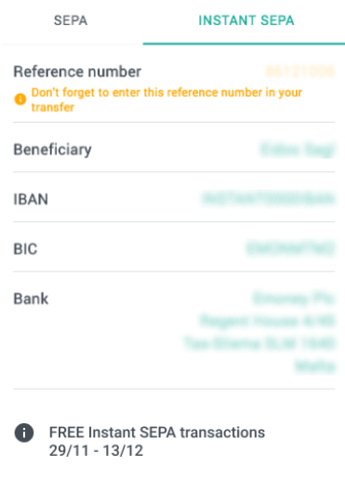  
Source: <https://www.cryptoninjas.net/wp-content/uploads/sepaeidoo.png>

The implementation of Instant SEPA, together with the already known feature of being a non-custodial crypto wallet is nothing more than the confirmation of Eidoo's commitment to ensure our users complete control of their funds.

**Take control of your money now, both crypto and fiat, by simply installing the** [**Eidoo wallet**](https://eidoo.io/crypto-wallet) **and order your** [**EidooCARD**](https://site.moneyfold.co.uk/eidoo-card)**.**